Include JavaScript in HTML

<script src="script.js" defer></script>

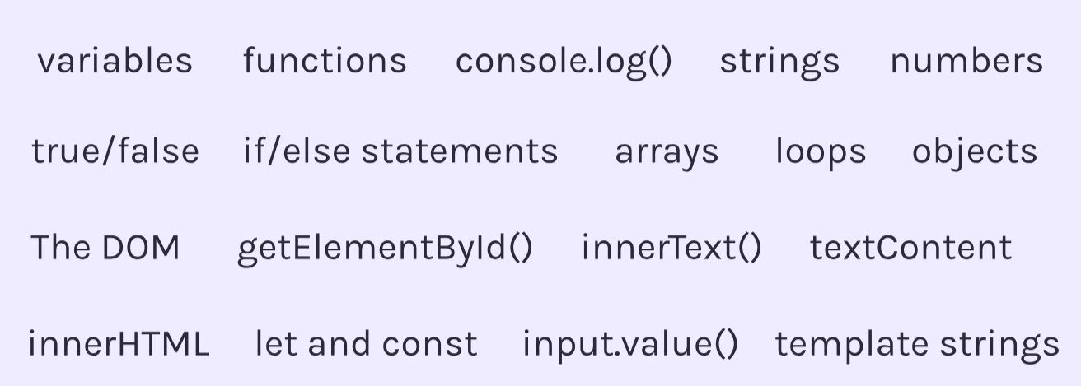

*JavaScript is case sensitive.*

1.Variables

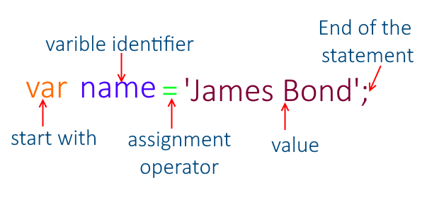

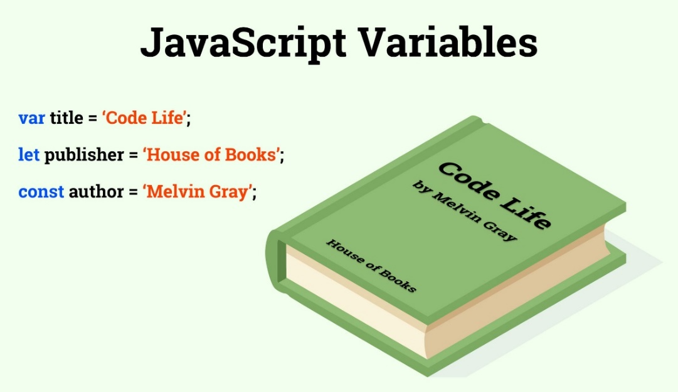

*Difference between var, let, const.*

* Var is globally scoped but let and const are block scoped.
* 7 Primitive Datatypes: Boolean, String, Symbol, Number, Null, BigInt, Undefined.
* Non-Primitive Datatypes: Objects, Prompt(to take input), Alert(alert box)

2.Functions

Parameters and arguments

Outputs and Return values

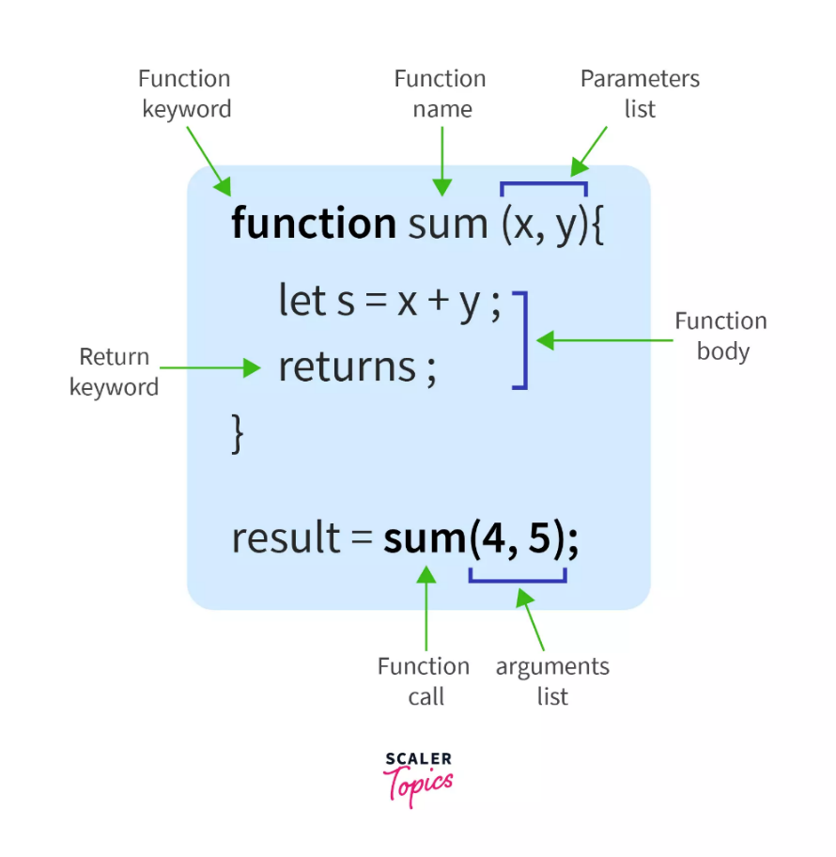

*Random function*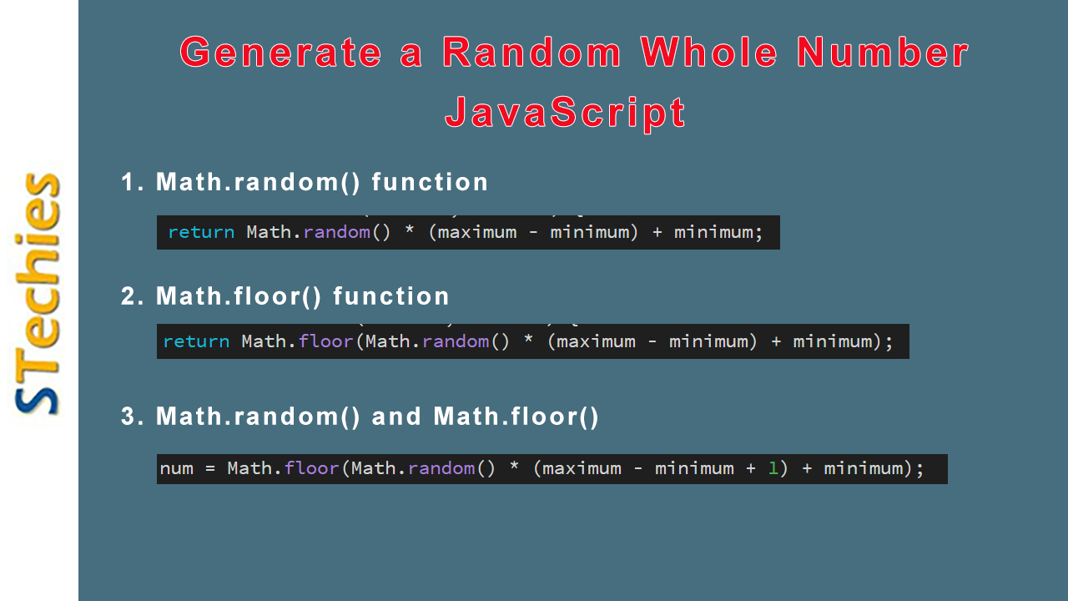

3.Console.log () : to print

4.Strings

Alert message

Prompt //tweet input

Slicing and extraction part of string

1. *Str.length*
2. *Str.toUpperCase()*
3. *Str.toLowerCase()*
4. *Str.Slice(2,5) //start=2 till 4*
5. *Str.slice(2) //start=2 till end*
6. *Str.replace(“a”,”b”)*
7. *Str.concat(“”)*
8. *Str.trim() //to remove*

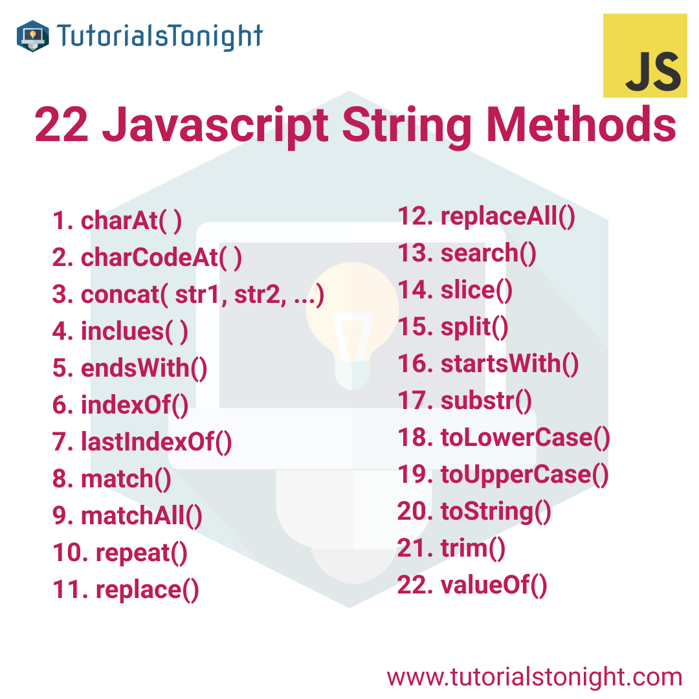

*Template Literals*

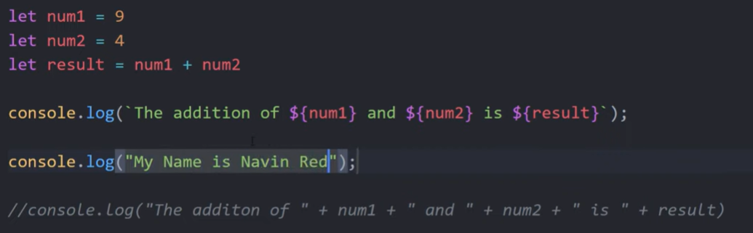

5.Numbers

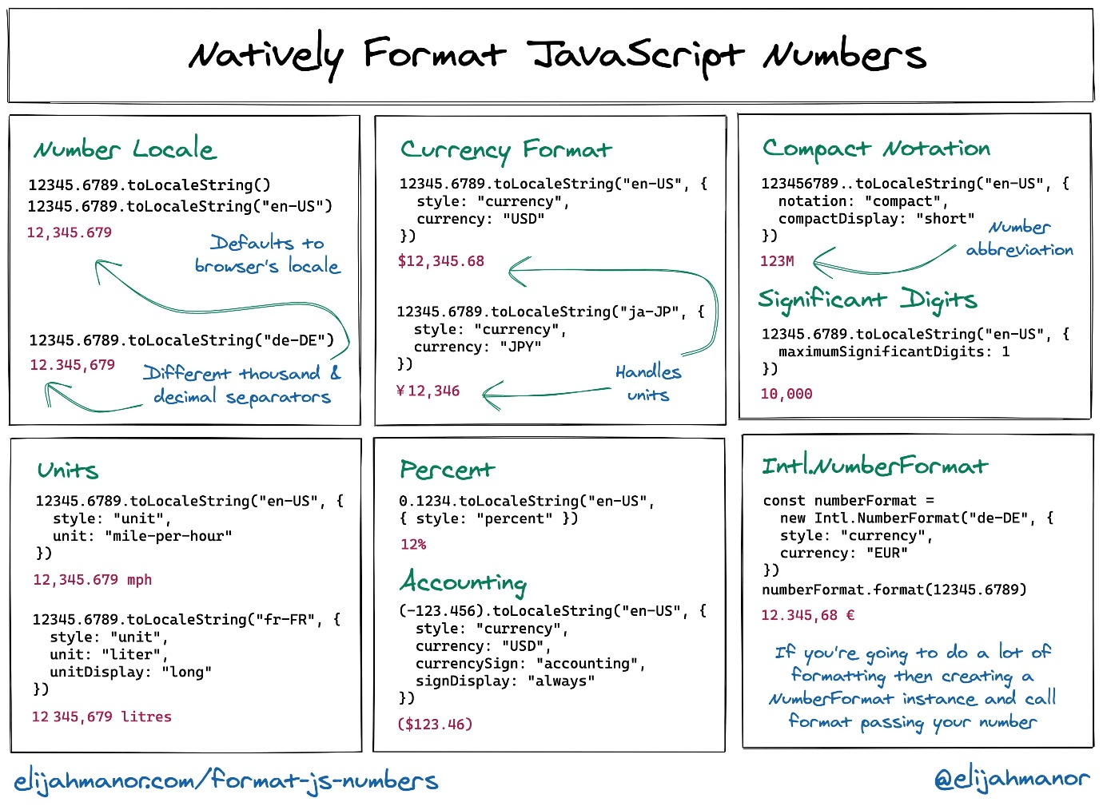

6.True/False

7.Conditionals (If/Else)

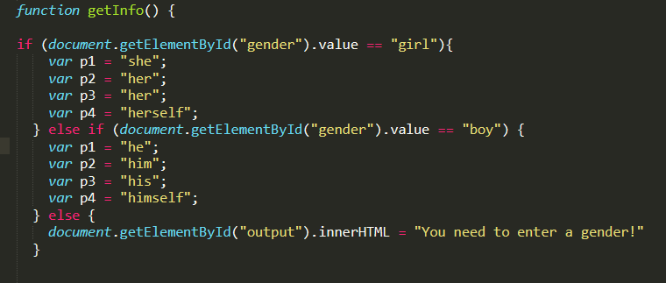

*Ternary operator*

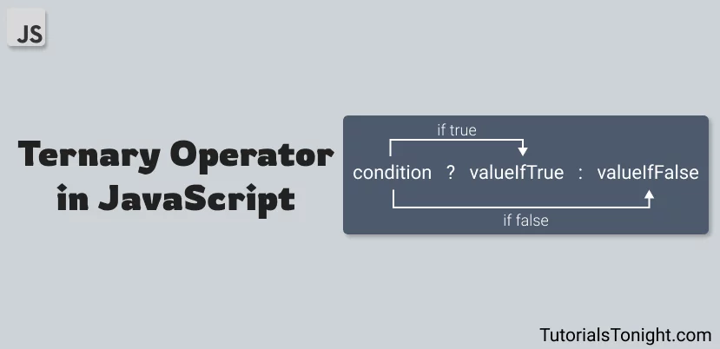

*Switch case*

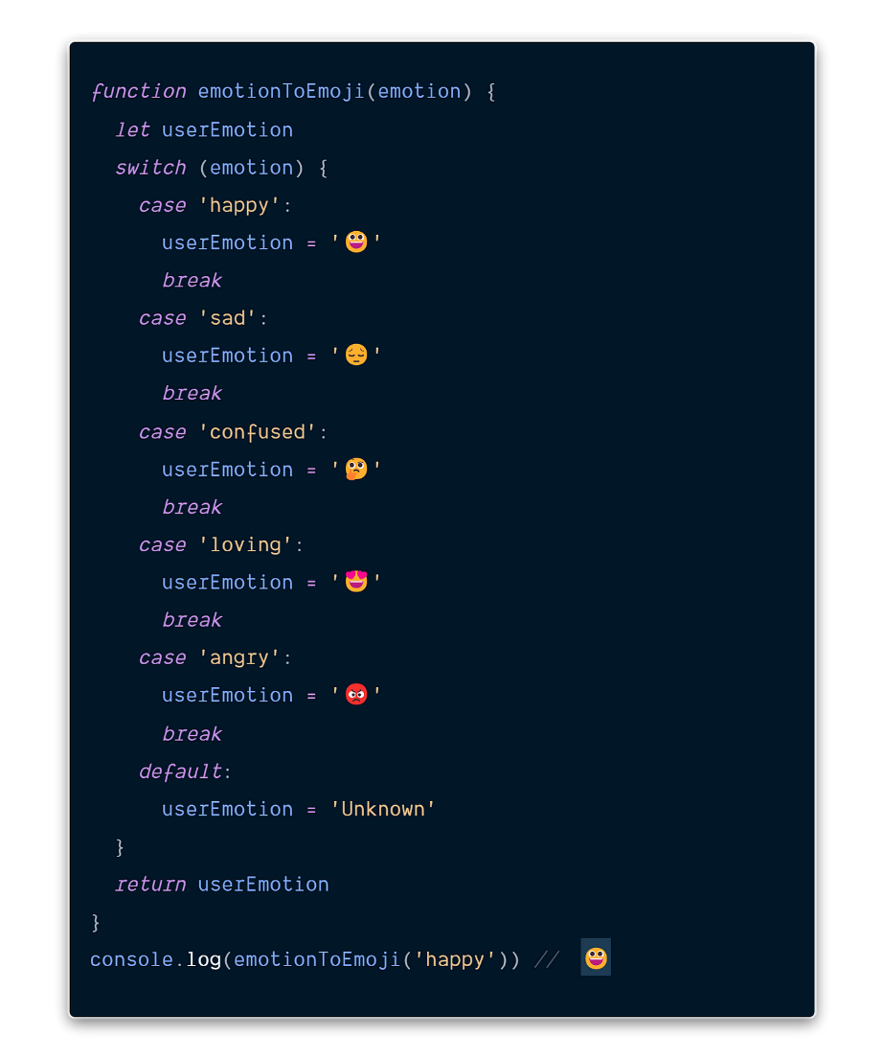

8.Arrays

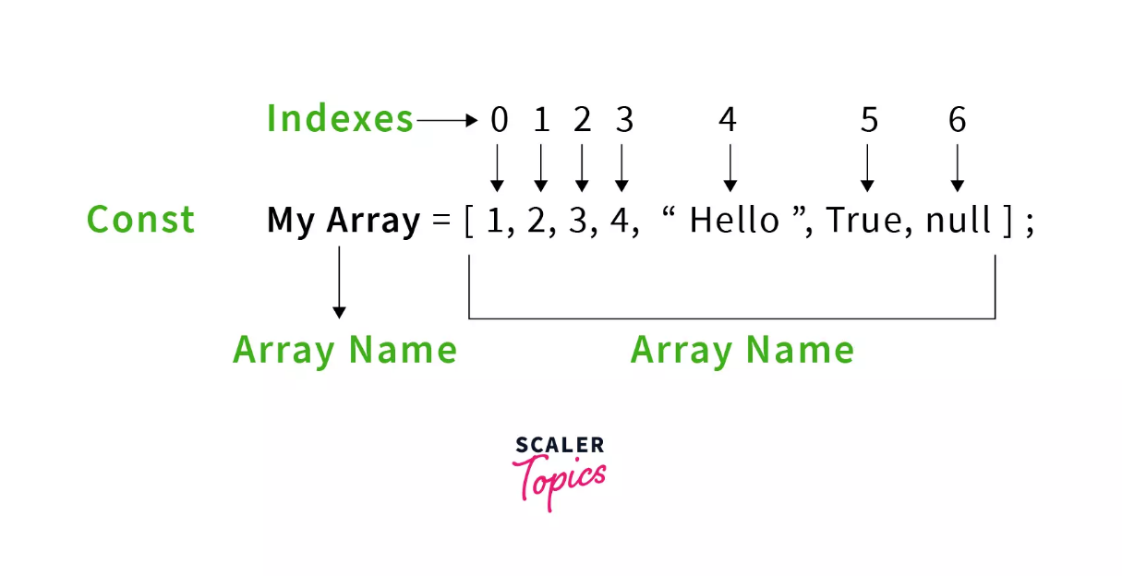

*Methods in array*

1. *Arr.toString()*
2. *Arr.join(“a”)*
3. *Arr.pop() //remove last element of same array*
4. *Arr.push(20) //add element and return length*
5. *Arr.shift()*
6. *delete arr[0] //delete the element at 0th index*
7. *arr.concat(arr2)*
8. *arr.sort() //it sort alphabetically*
9. *arr.reverse()*
10. *arr.splice() //splice can be used to add new items to an array*

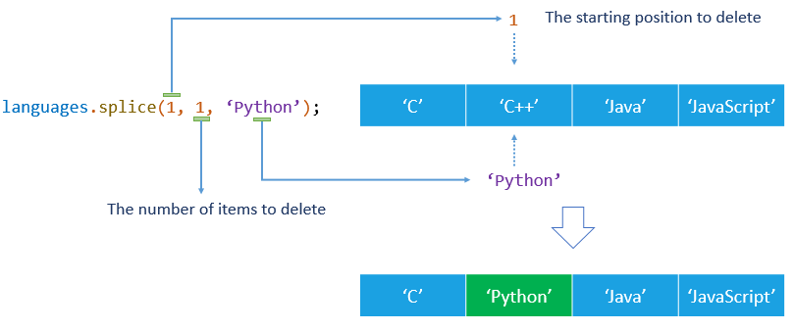

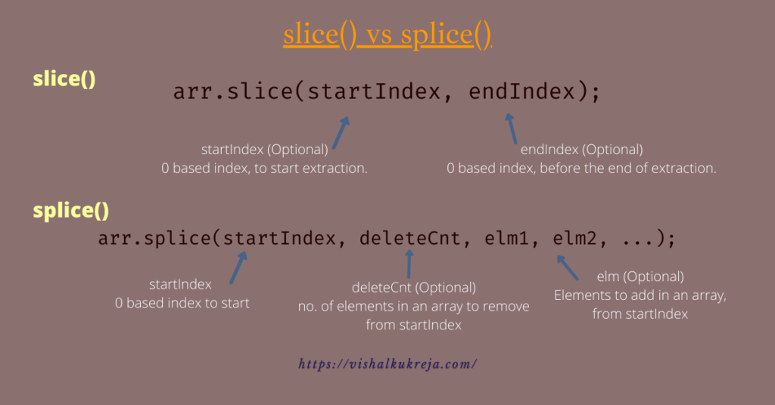

*11.arr.slice()*

9.Loops

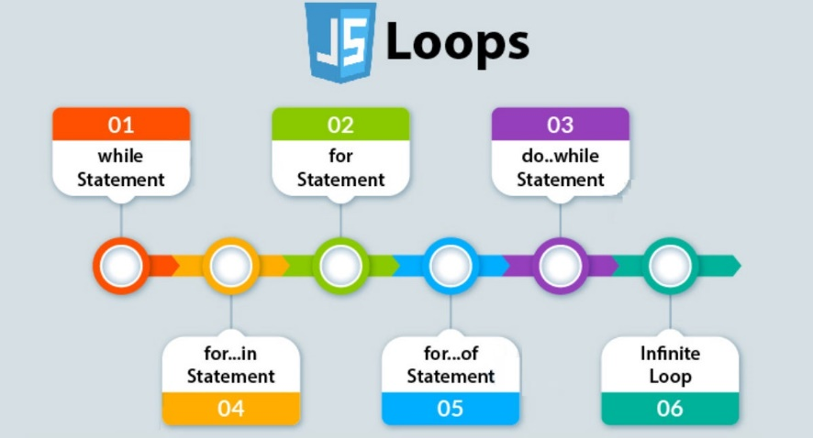

While

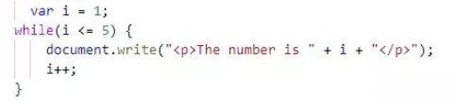

For loop

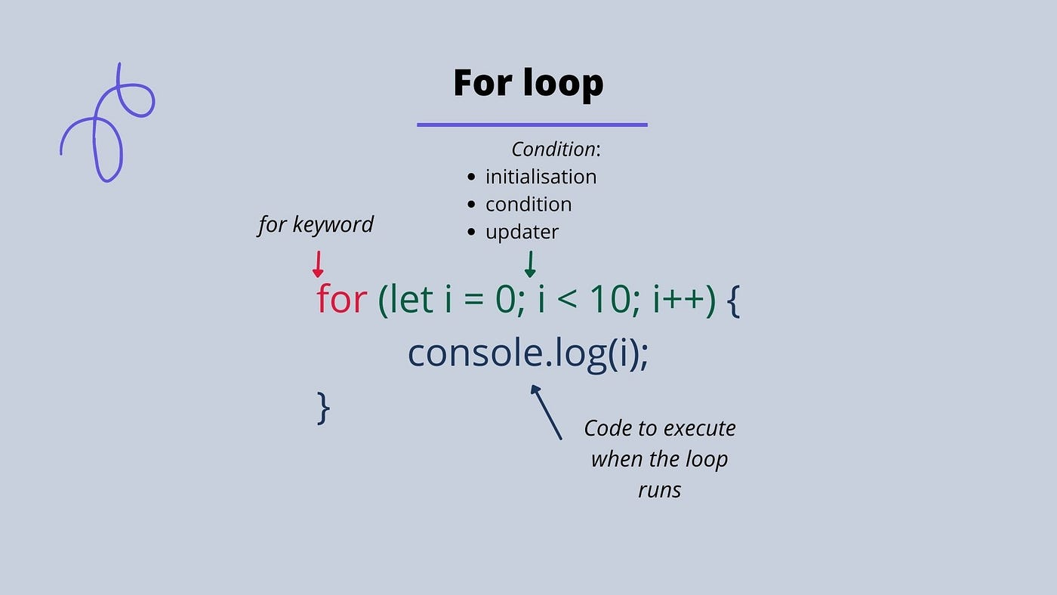

Do While

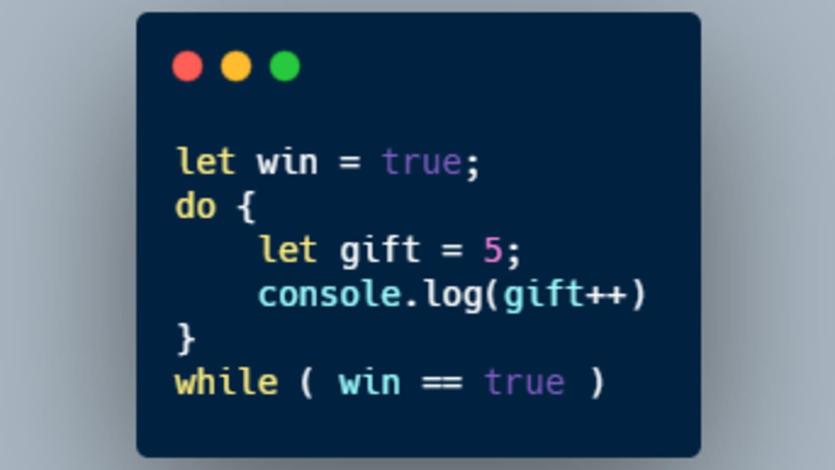

Difference between (for each , for of, for in )

<https://youtu.be/YWyr7Nug2oc?si=P1vatk_X-m_2jyWA>

For each

For in

For of

Infinite loop

10.Objects: *are non-primitive datatypes (as like Dictionaries in Python).*

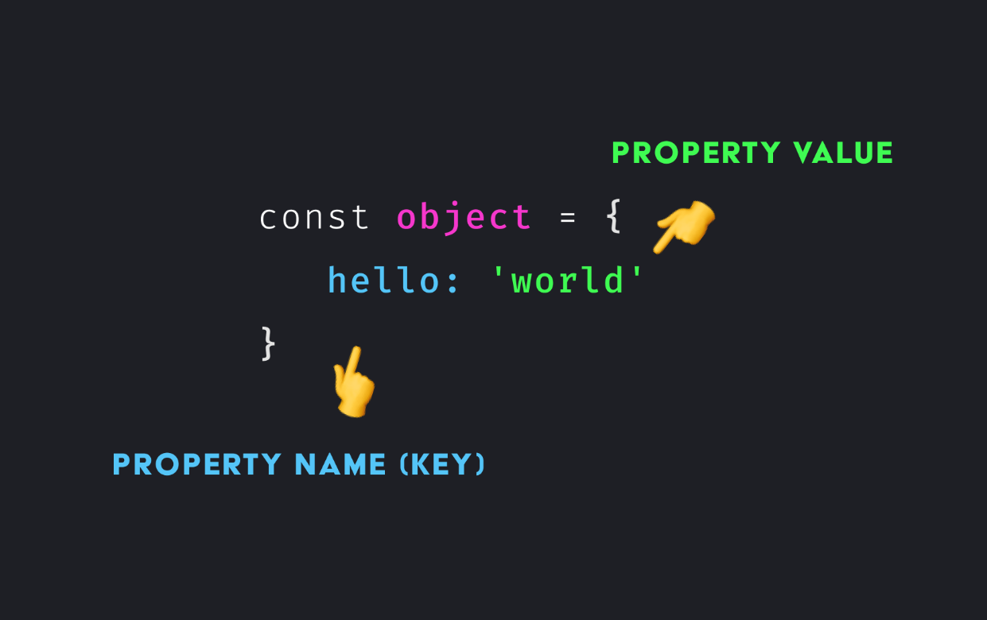

Access the object by : *object[“hello”]*

Object Inheritance Classes

*JavaScript me classes kaise work karte hai*

*JavaScript me Objects kaise work karte hai*

*Prototypes kya hote hai*

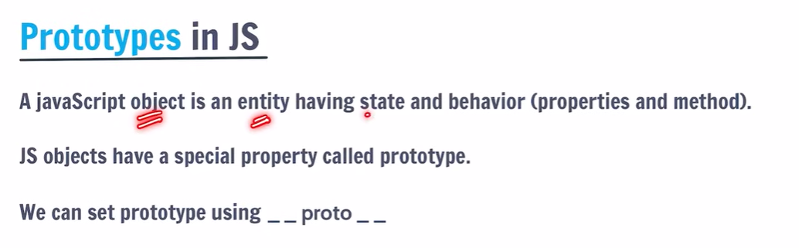

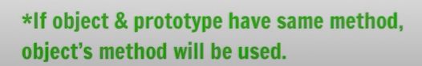

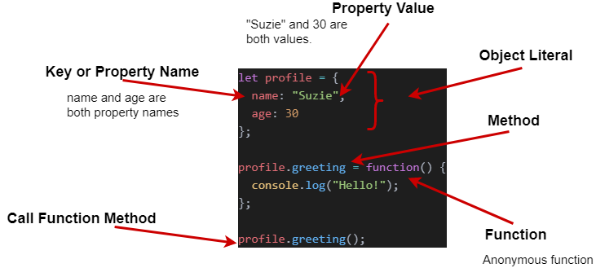

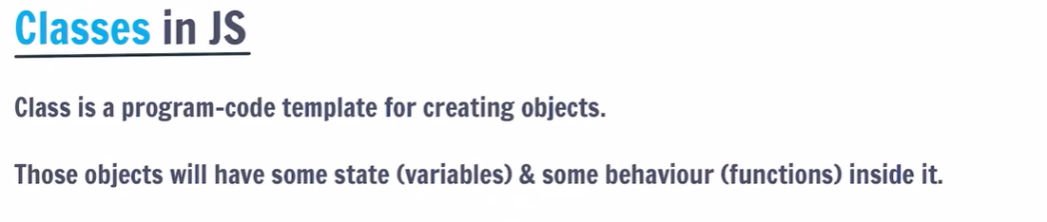

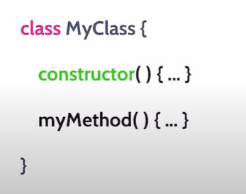

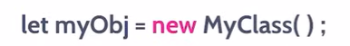

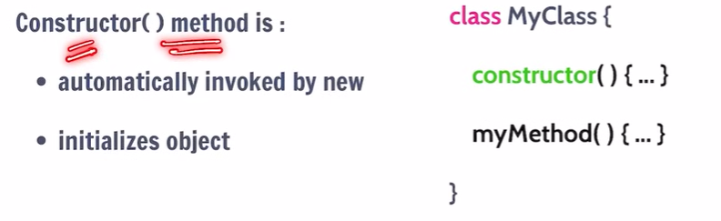

**

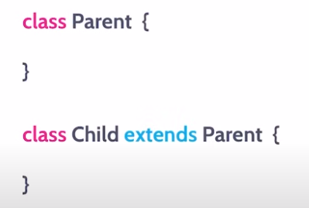

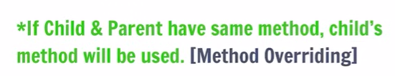

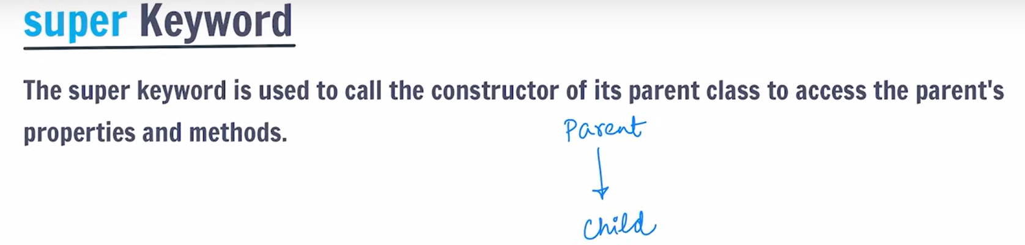

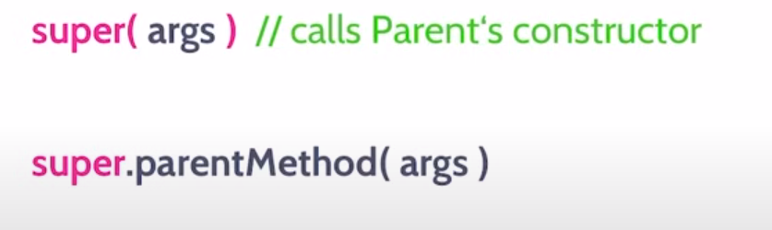

*Method overriding kya hote hai*

*Super keyword kaise kaam karta hai*

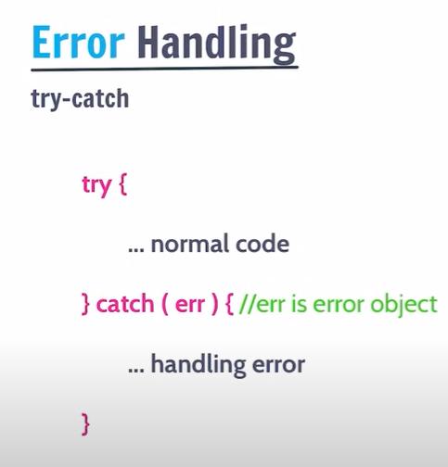

11.The DOM

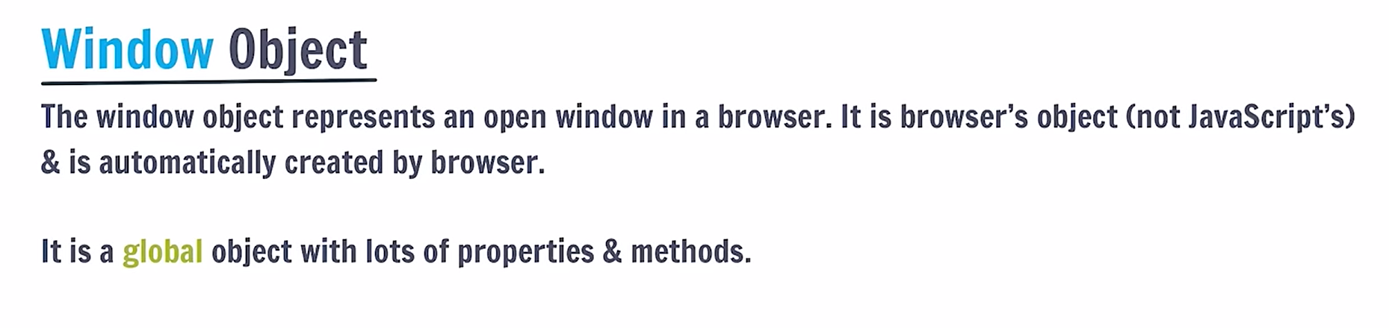

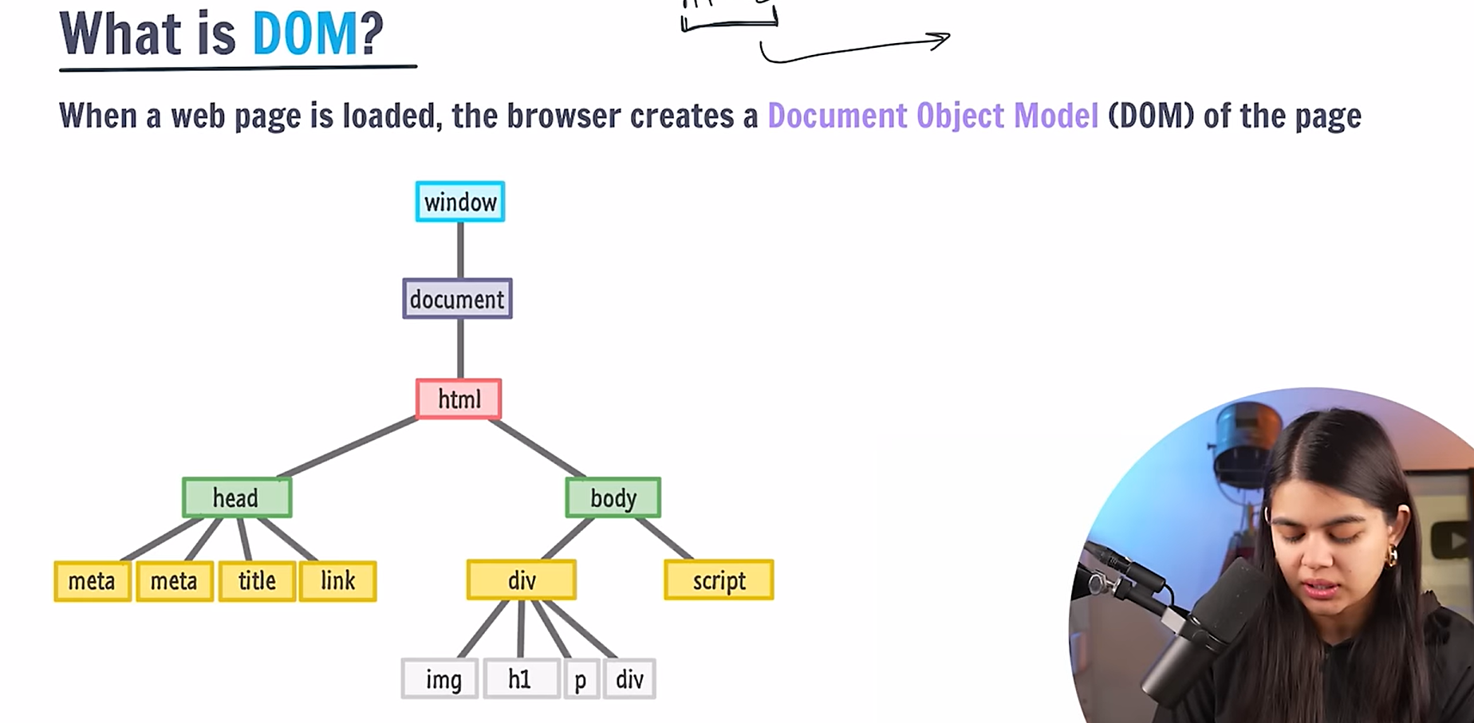

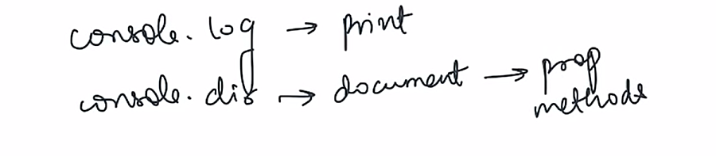

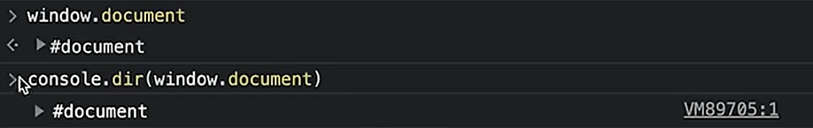

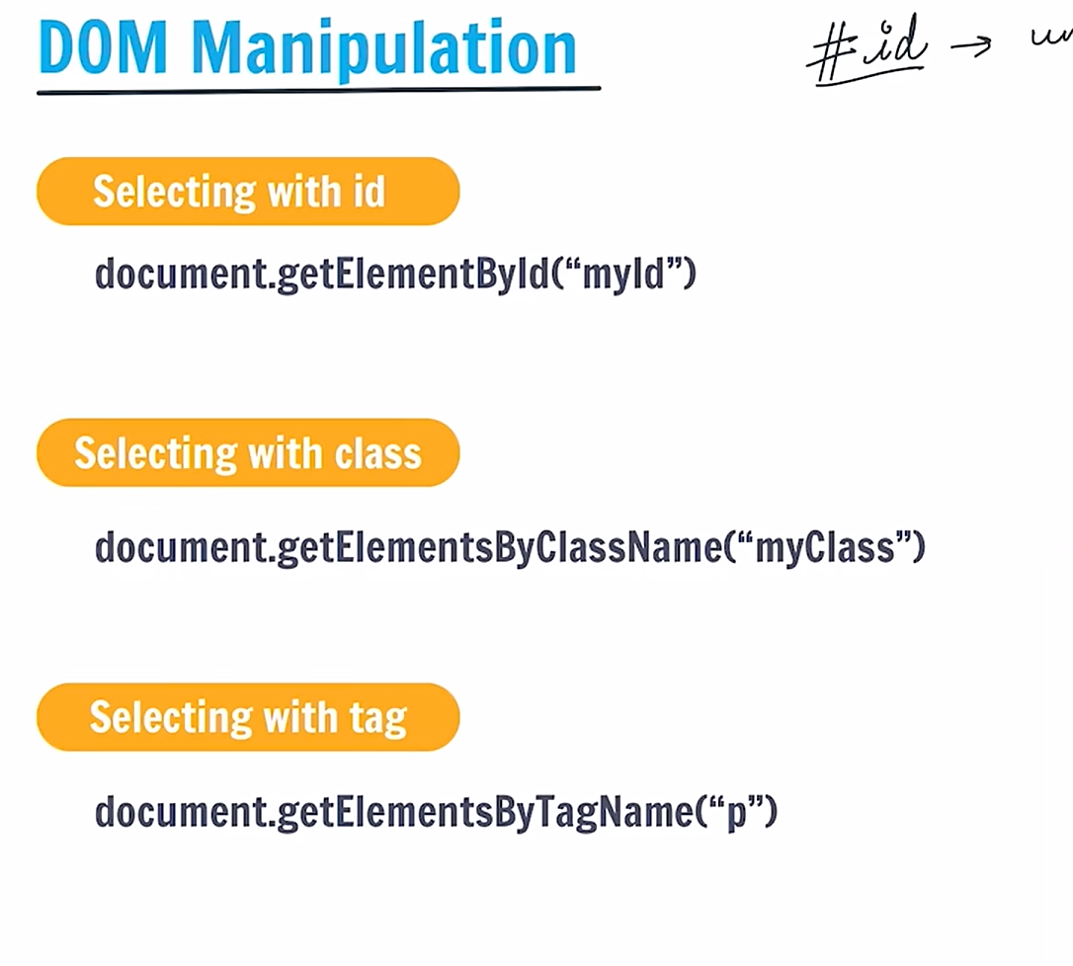

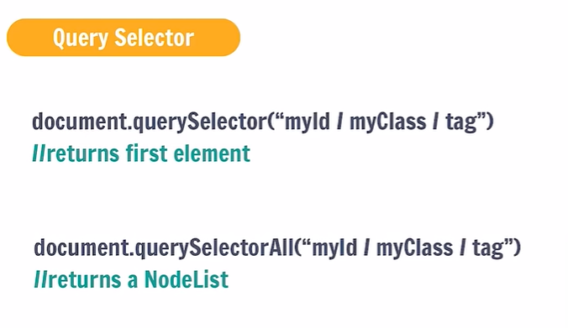

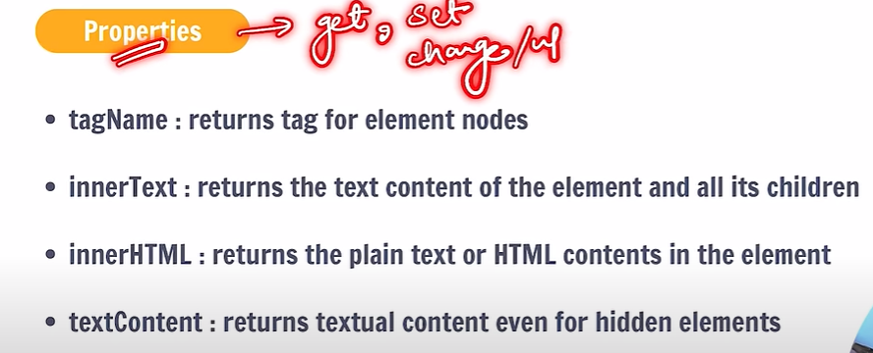

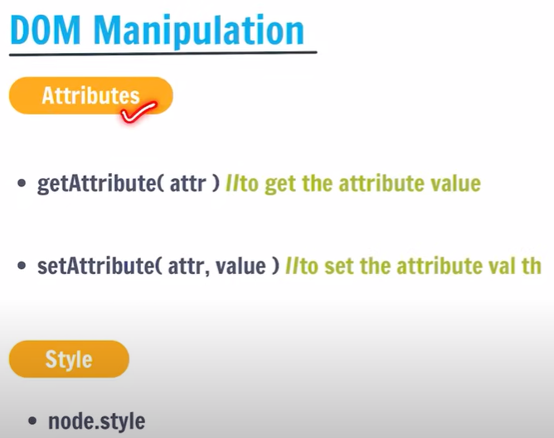

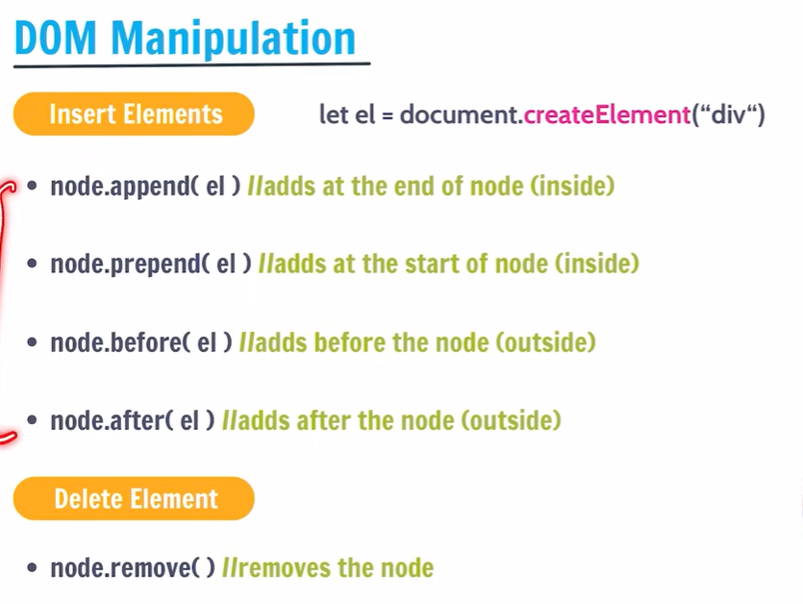

12. getElementById()

13.innerText()

14.textContent

15.innerHTML

16.let and const

17.input.value()

18.Template strings

EVENT Handling in ***JavaScript***





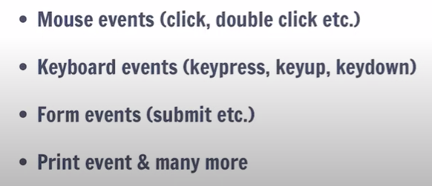

…Prefer MDN docs for more function

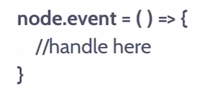Syntax for adding an event in javascript…

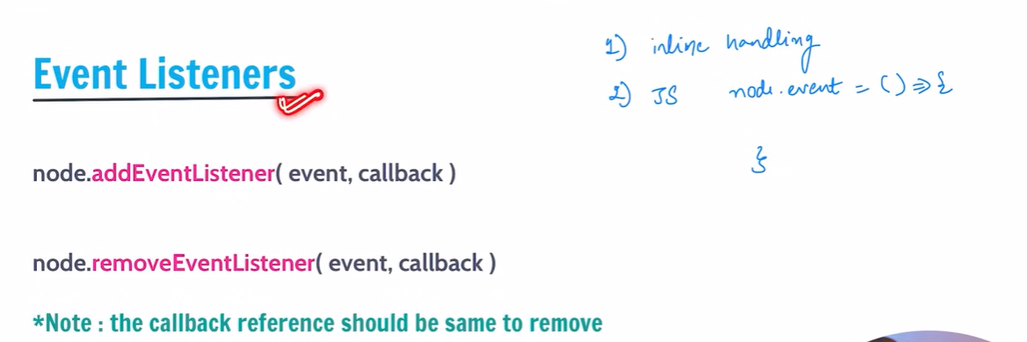

Operators

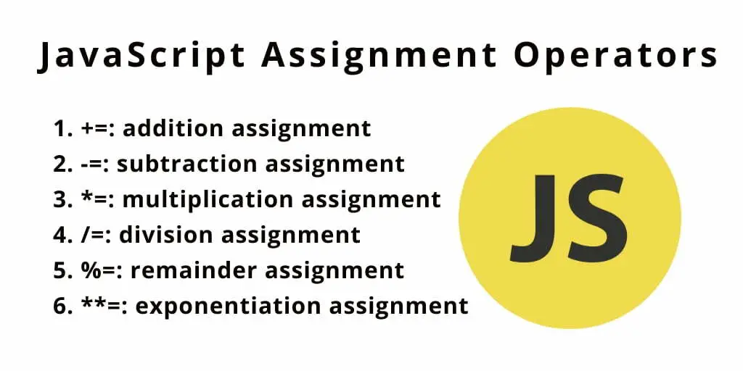

Advance part of JavaScript



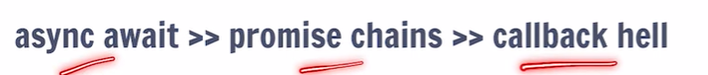

Most Important topics

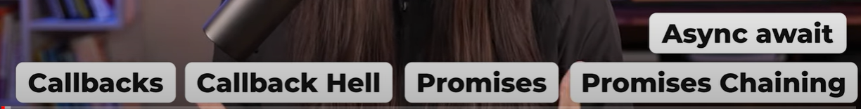

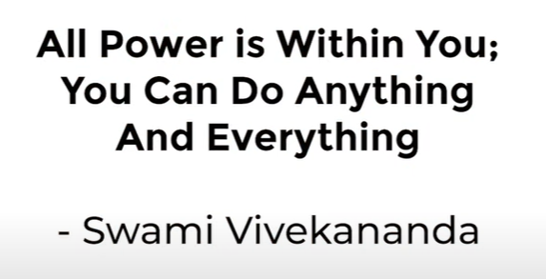



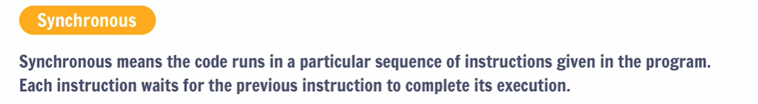

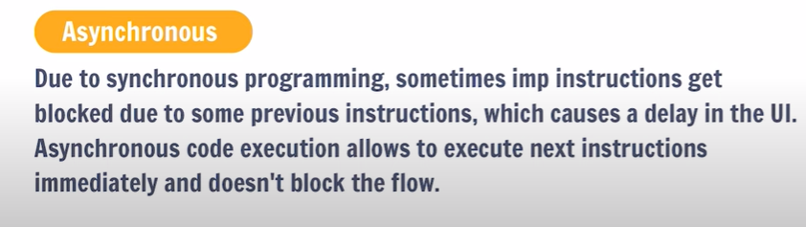

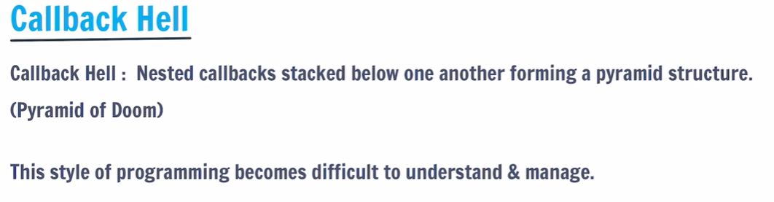

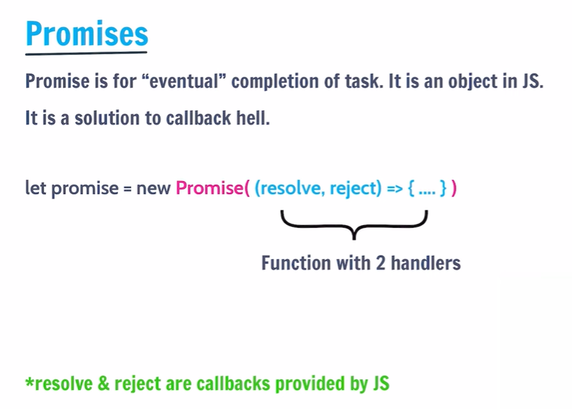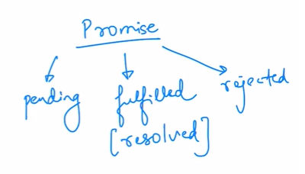

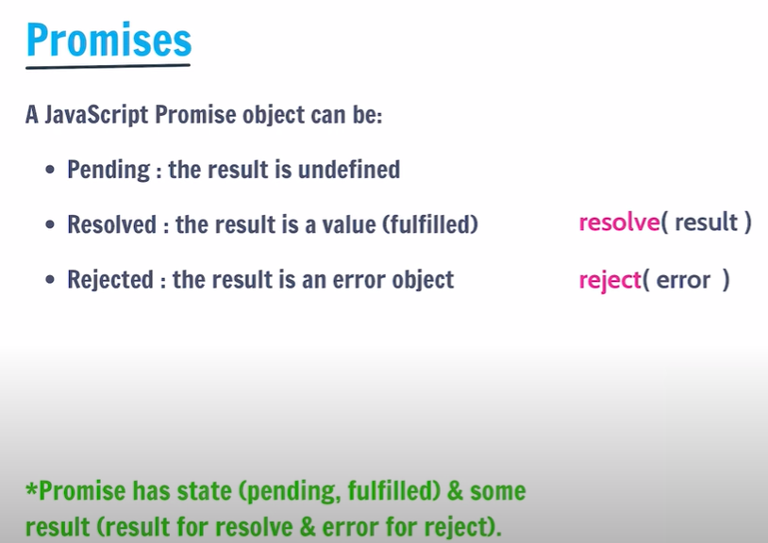

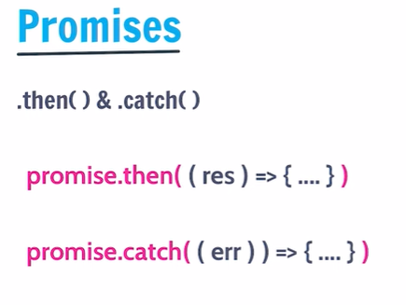

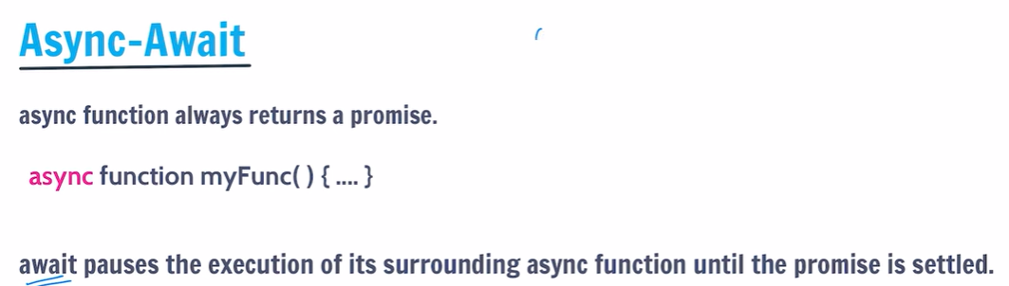



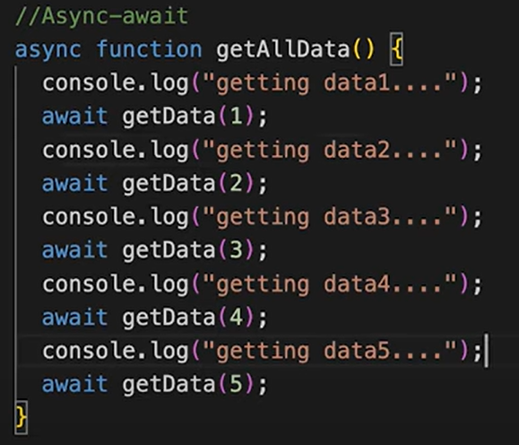

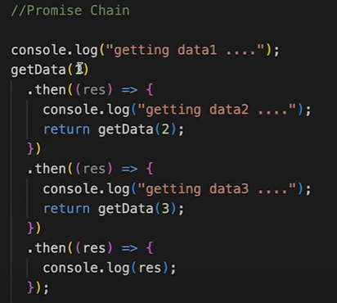

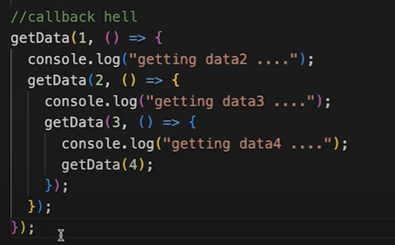

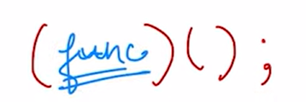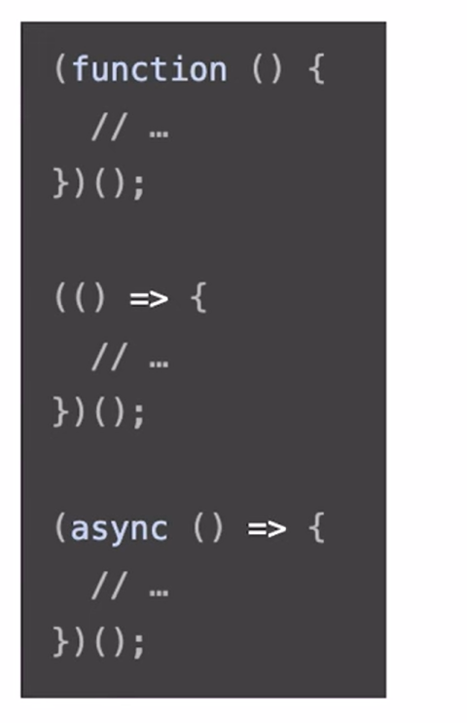

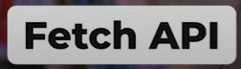

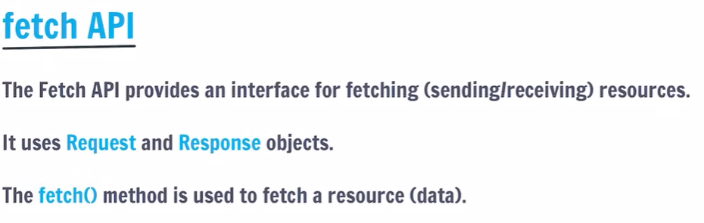



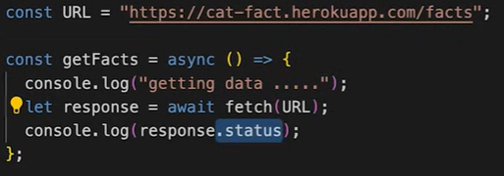

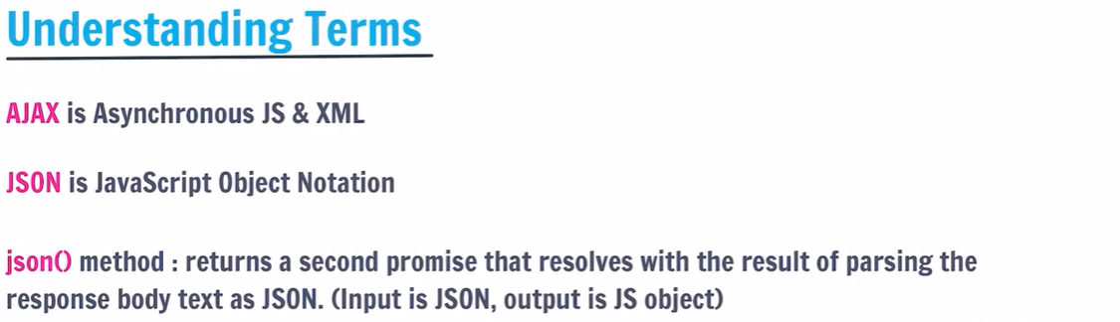

Map, Filter and Reduce

1.Map

2.Filter

3.Reduce

RYAN DAHL

V8 engine in C++

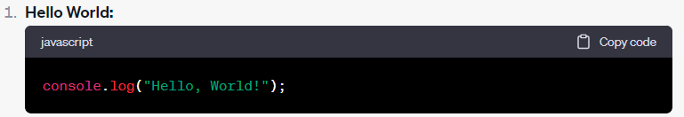

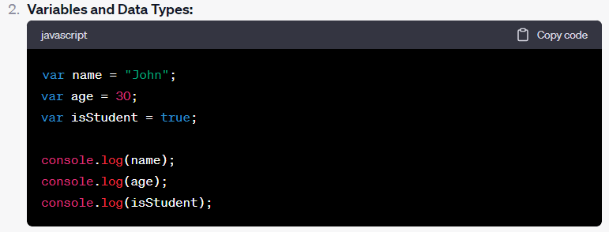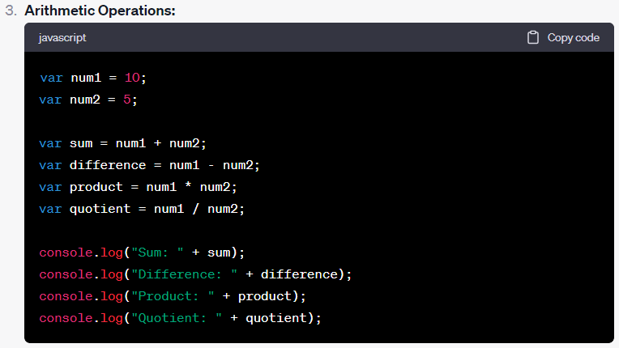

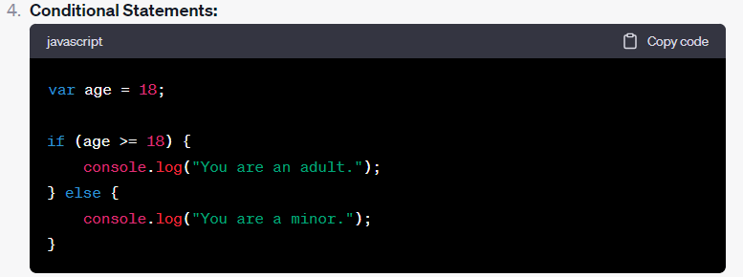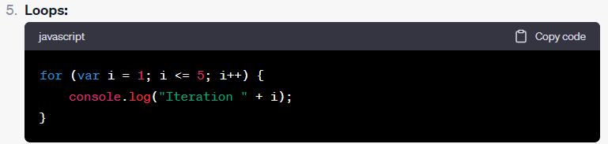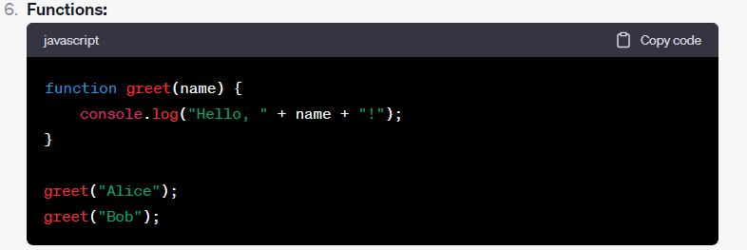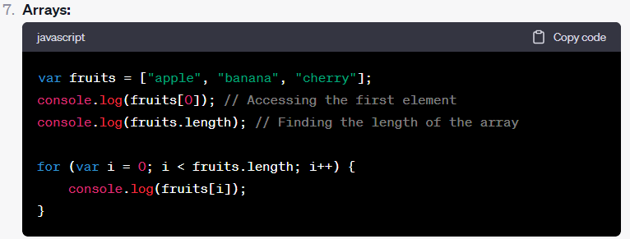

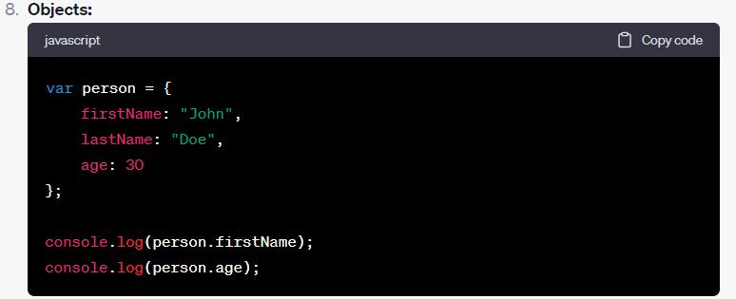

9.Event Handling (in the Browser)

<button id="myButton">Click Me</button>

<script>

document.getElementById("myButton").addEventListener("click", function() {

alert("Button clicked!");

});

</script>

10. Async/Await (Asynchronous Programming)

async function fetchData() {

const response = await fetch('https://jsonplaceholder.typicode.com/posts/1');

const data = await response.json();

console.log(data);

}

fetchData();

ToDoList

|  |
| --- |
| <!DOCTYPE html>  <html>  <head>  <title>To-Do List</title>  </head>  <body>  <h1>To-Do List</h1>  <input type="text" id="task" placeholder="Add a task">  <button onclick="addTask()">Add Task</button>  <ul id="taskList"></ul>    <script>  function addTask() {  const taskInput = document.getElementById('task');  const taskList = document.getElementById('taskList');  const taskText = taskInput.value;  if (taskText) {  const li = document.createElement('li');  li.textContent = taskText;  taskList.appendChild(li);  taskInput.value = '';  }  }  </script>  </body>  </html> |

SimpleCalculator

|  |
| --- |
| …………Needs some correction ……  <!DOCTYPE html>  <html>  <head>  <title>Calculator</title>  </head>  <body>  <h1>Calculator</h1>  <input type="text" id="display" readonly>  <button onclick="clearDisplay()">C</button>  <button onclick="appendToDisplay('7')">7</button>  <!-- Add buttons for other digits and operations -->  <button onclick="calculate()">=</button>    <script>  let displayValue = '';  function appendToDisplay(value) {  displayValue += value;  document.getElementById('display').value = displayValue;  }  function clearDisplay() {  displayValue = '';  document.getElementById('display').value = '';  }  function calculate() {  try {  displayValue = eval(displayValue);  document.getElementById('display').value = displayValue;  } catch (error) {  document.getElementById('display').value = 'Error';  }  }  </script>  </body>  </html> |

RandomQuoteGenerator

|  |
| --- |
| <!DOCTYPE html>  <html>  <head>  <title>Random Quote Generator</title>  </head>  <body>  <h1>Random Quote</h1>  <p id="quote">Loading...</p>    <script>  const quotes = [  "The only way to do great work is to love what you do. - Steve Jobs",  "Innovation distinguishes between a leader and a follower. - Steve Jobs",  "Your time is limited, so don't waste it living someone else's life. - Steve Jobs"  ];  const randomIndex = Math.floor(Math.random() * quotes.length);  const randomQuote = quotes[randomIndex];  document.getElementById('quote').textContent = randomQuote;  </script>  </body>  </html> |